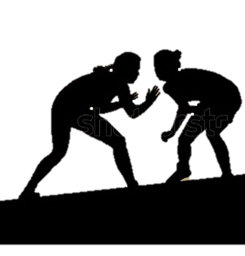
Boiling Springs Girls Wrestling

Join us for a girl’s only practice to find out what it is all about and meet the coaches
Who: Any 7th through 12th grade girls and parents interested in learning about the fastest growing sport in the state. No experience or equipment is needed.
When: October 25th and November 1st 6:30 to 8:00 P.M.
Where: Boiling Springs high school gym
What: learn the basic rules and skills involved with the sport of wrestling, as well as, the ins and outs of the growth of girls wrestling.
Bubblergirlswrestling@gmail.com

